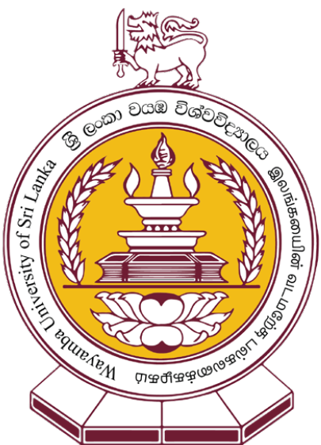

Faculty of Technology

Wayamba University of Sri Lanka

**Application for**

**Diploma in Construction Labour Productivity and Performance Management – 2021/22**  
(Application Closing Date: 25.05.2021)

1. **Personal Details**

|  |  |  |  |  |  |
| --- | --- | --- | --- | --- | --- |
| Title (Dr/Mr./Mrs/Miss/Ms/Other) |  | | | | |
| Full Name |  | | | | |
| Gender (Please tick) | Male | |  | Female |  |
| Date of Birth (DD/MM/YYYY) |  | | | | |
| NIC Number |  | | | | |
| Postal Address |  | | | | |
| Contact Numbers | Home |  | | | |
| Mobile |  | | | |
| Office |  | | | |
| Email |  | | | | |

1. **Current Employment Details** (Attach copies of certificates/letters)

|  |  |
| --- | --- |
| Designation |  |
| Name of the Employer |  |
| Project Name |  |
| Address of the Current Workplace |  |
| Nature of Duties Performed |  |

1. **Other Work / Training Experience** (Attach copies of certificates/letters)

|  |  |  |  |
| --- | --- | --- | --- |
| Company /Organization | Designation | Nature of Duties Performed | Period |
|  |  |  |  |

1. **Educational Qualification** (Attach copies of certificates / results sheets)

|  |  |
| --- | --- |
| GCE Advanced Level | Year(s) of the Examination(s), Subjects and Grades |
|  |
| GCE Ordinary Level | Year(s) of the Examination(s), Subjects and Grades |
|  |
| Other Qualifications | Specify the Institute Names, Qualifications, Subjects, Grades and Year of Completion |
|  |

1. **Professional Qualification** (Attach copies of certificates)

|  |
| --- |
| Specify the Institute Names, Qualifications, Subjects, Grades and Year of Completion |
|  |

1. **Other Achievements**

|  |
| --- |
|  |

1. **Extracurricular Activities**

|  |
| --- |
|  |

1. **Two Non Related Referees**

|  |  |
| --- | --- |
| 1. Name, Designation & Contact Details | 1. Name, Designation & Contact Details |

1. **Reason for Selecting this Programme**

|  |  |  |
| --- | --- | --- |
|  | Yes | No |
| I am directly involved in this field. |  |  |
| I am generally interested in the subject. |  |  |
| The course might be helpful for my present employment. |  |  |
| The diploma obtained could be used to further my higher education. |  |  |
| The programme might help me to obtain an employment in the field. |  |  |
| Other (Specify): | | |

1. **Mode of Payment of Programme Fee**

|  |  |  |  |  |  |
| --- | --- | --- | --- | --- | --- |
| From personal funds |  | By employer |  | Other (Specify) |  |

1. **Declaration**

|  |  |  |  |
| --- | --- | --- | --- |
| I do hereby declare that the particulars given in this application are accurate to the best of my knowledge and I am aware that the Wayamba University of Sri Lanka reserves the rights to alter or withdraw any offer made on incorrect information furnished by me. | | | |
| Date |  | Signature |  |

**How did you know about the Diploma in Construction Labour Productivity and Performance Management (DCLPPM) programme?**

|  |  |  |  |  |  |  |  |
| --- | --- | --- | --- | --- | --- | --- | --- |
|  | Word of Mouth |  | Newspapers |  | Facebook |  | University Website |

|  |  |  |  |  |  |
| --- | --- | --- | --- | --- | --- |
|  | Seminar |  | Co-workers |  | Company Recommendation |

Others (Specify): ……………………………………………..

**Application Documents**

Attach the following documents with the duly filled application.

* **Copy of the NIC**
* **Photocopy of the birth certificate**
* **An updated curriculum vitae (CV)**
* **Photocopies of the relevant certificates/letters (Educational/Professional qualifications, work experience, Etc.)**

Note: If the results are pending of any educational qualification claimed in the application form, write a letter addressing to the director mentioning that the relevant examination results are pending and ready to submit soon after the relevant results are released.

* **Two recently taken photographs (Passport size)**
* **Two self-addressed stamped (worth Rs.45/-) 23cm x 10cm envelopes**
* **Duplicate of the Payment Slip of Rs. 500.00 application fee** (Applications without the bank payment receipt will not be accepted)

Application processing fee Rs. 500.00 should be deposited to the below mentioned bank account at any branch of Bank of Ceylon.

**Account Name: Wayamba University of Sri Lanka**

**Account no: 028 100 1515 86 123 (Current Account)**

**Bank: Peoples Bank - Kuliyapitiya Branch**

**Payment type/statement: Application Fee of DCLPPM 2021 - Bank**

**Duly filled application form** with all relevant documents and the duplicate of the payment slip should be posted via registered post to

**Director,**

**Diploma in Construction Labour Productivity and Performance Management,**

**Faculty of Technology,**

**Wayamba University of Sri Lanka,**

**Kuliyapitiya, 60200.**

Note: Please mention **‘Application for DCLPPM’** on the top left hand corner of the envelope.

(You are also advised to keep a photocopy of the application and the photocopy of the duplicate of the payment slip)

Application closing date: **25.05.2021**

For more details, contact us.

About the application process: Administrative Coordinator (T.P: 0373138054 / 0373976657)

About course information and career advises, contact

Sinhala (0770879053 / 0760122789 / 0714418150) ; Tamil (0774447663 / 0773030266 / 0777678003)

Faculty of Technology, Wayamba University of Sri Lanka, Kuliyapitiya.